MJ Transport ERP
Flow of Accounts — Analysis
A technical analysis of the Accounts module (Phase 6) as implemented in the codebase
backend/src (Node.js + Express + Prisma) and frontend/src/pages/accounts (Vue 3)
Prepared by: Claude Code (AI-assisted codebase analysis)
Date: 31 July 2026

Executive Summary
MJ Transport ERP's Accounts module implements the transportation billing/settlement cycle only — it is deliberately not general-purpose accounting software. There is no chart of accounts, no ledger, and no double-entry posting. Instead there are two parallel, trip-driven cash-flow tracks:
- Customer side (Receivables): completed trips are grouped into a Customer Invoice, against which Receipts and Credit Notes are recorded; an outstanding balance and status are recalculated automatically.
- Supplier side (Payables): completed (market-truck) trips generate Supplier Payments — a flat ledger with no status machine and no ceiling check.
A third, purely derived layer (Trip Financial Lines, the Accounts Dashboard, and 8 Accounts Reports) reads the above back for profitability and cash-position reporting, but nothing is stored twice — profit and outstanding balances are computed on demand.
Note: the project's top-level README.md describes Accounts as an unbuilt placeholder module. That is out of date — this analysis is based on the actual implemented code (Phase 6 of the build) in backend/src and frontend/src/pages/accounts.

1. Flow Diagram
The diagram below traces the complete money trail: from an Intent's freight price, through Trip execution and completion, into the customer invoicing cycle on one branch and the supplier payment ledger on the other, ending in the read-only reporting layer at the bottom.
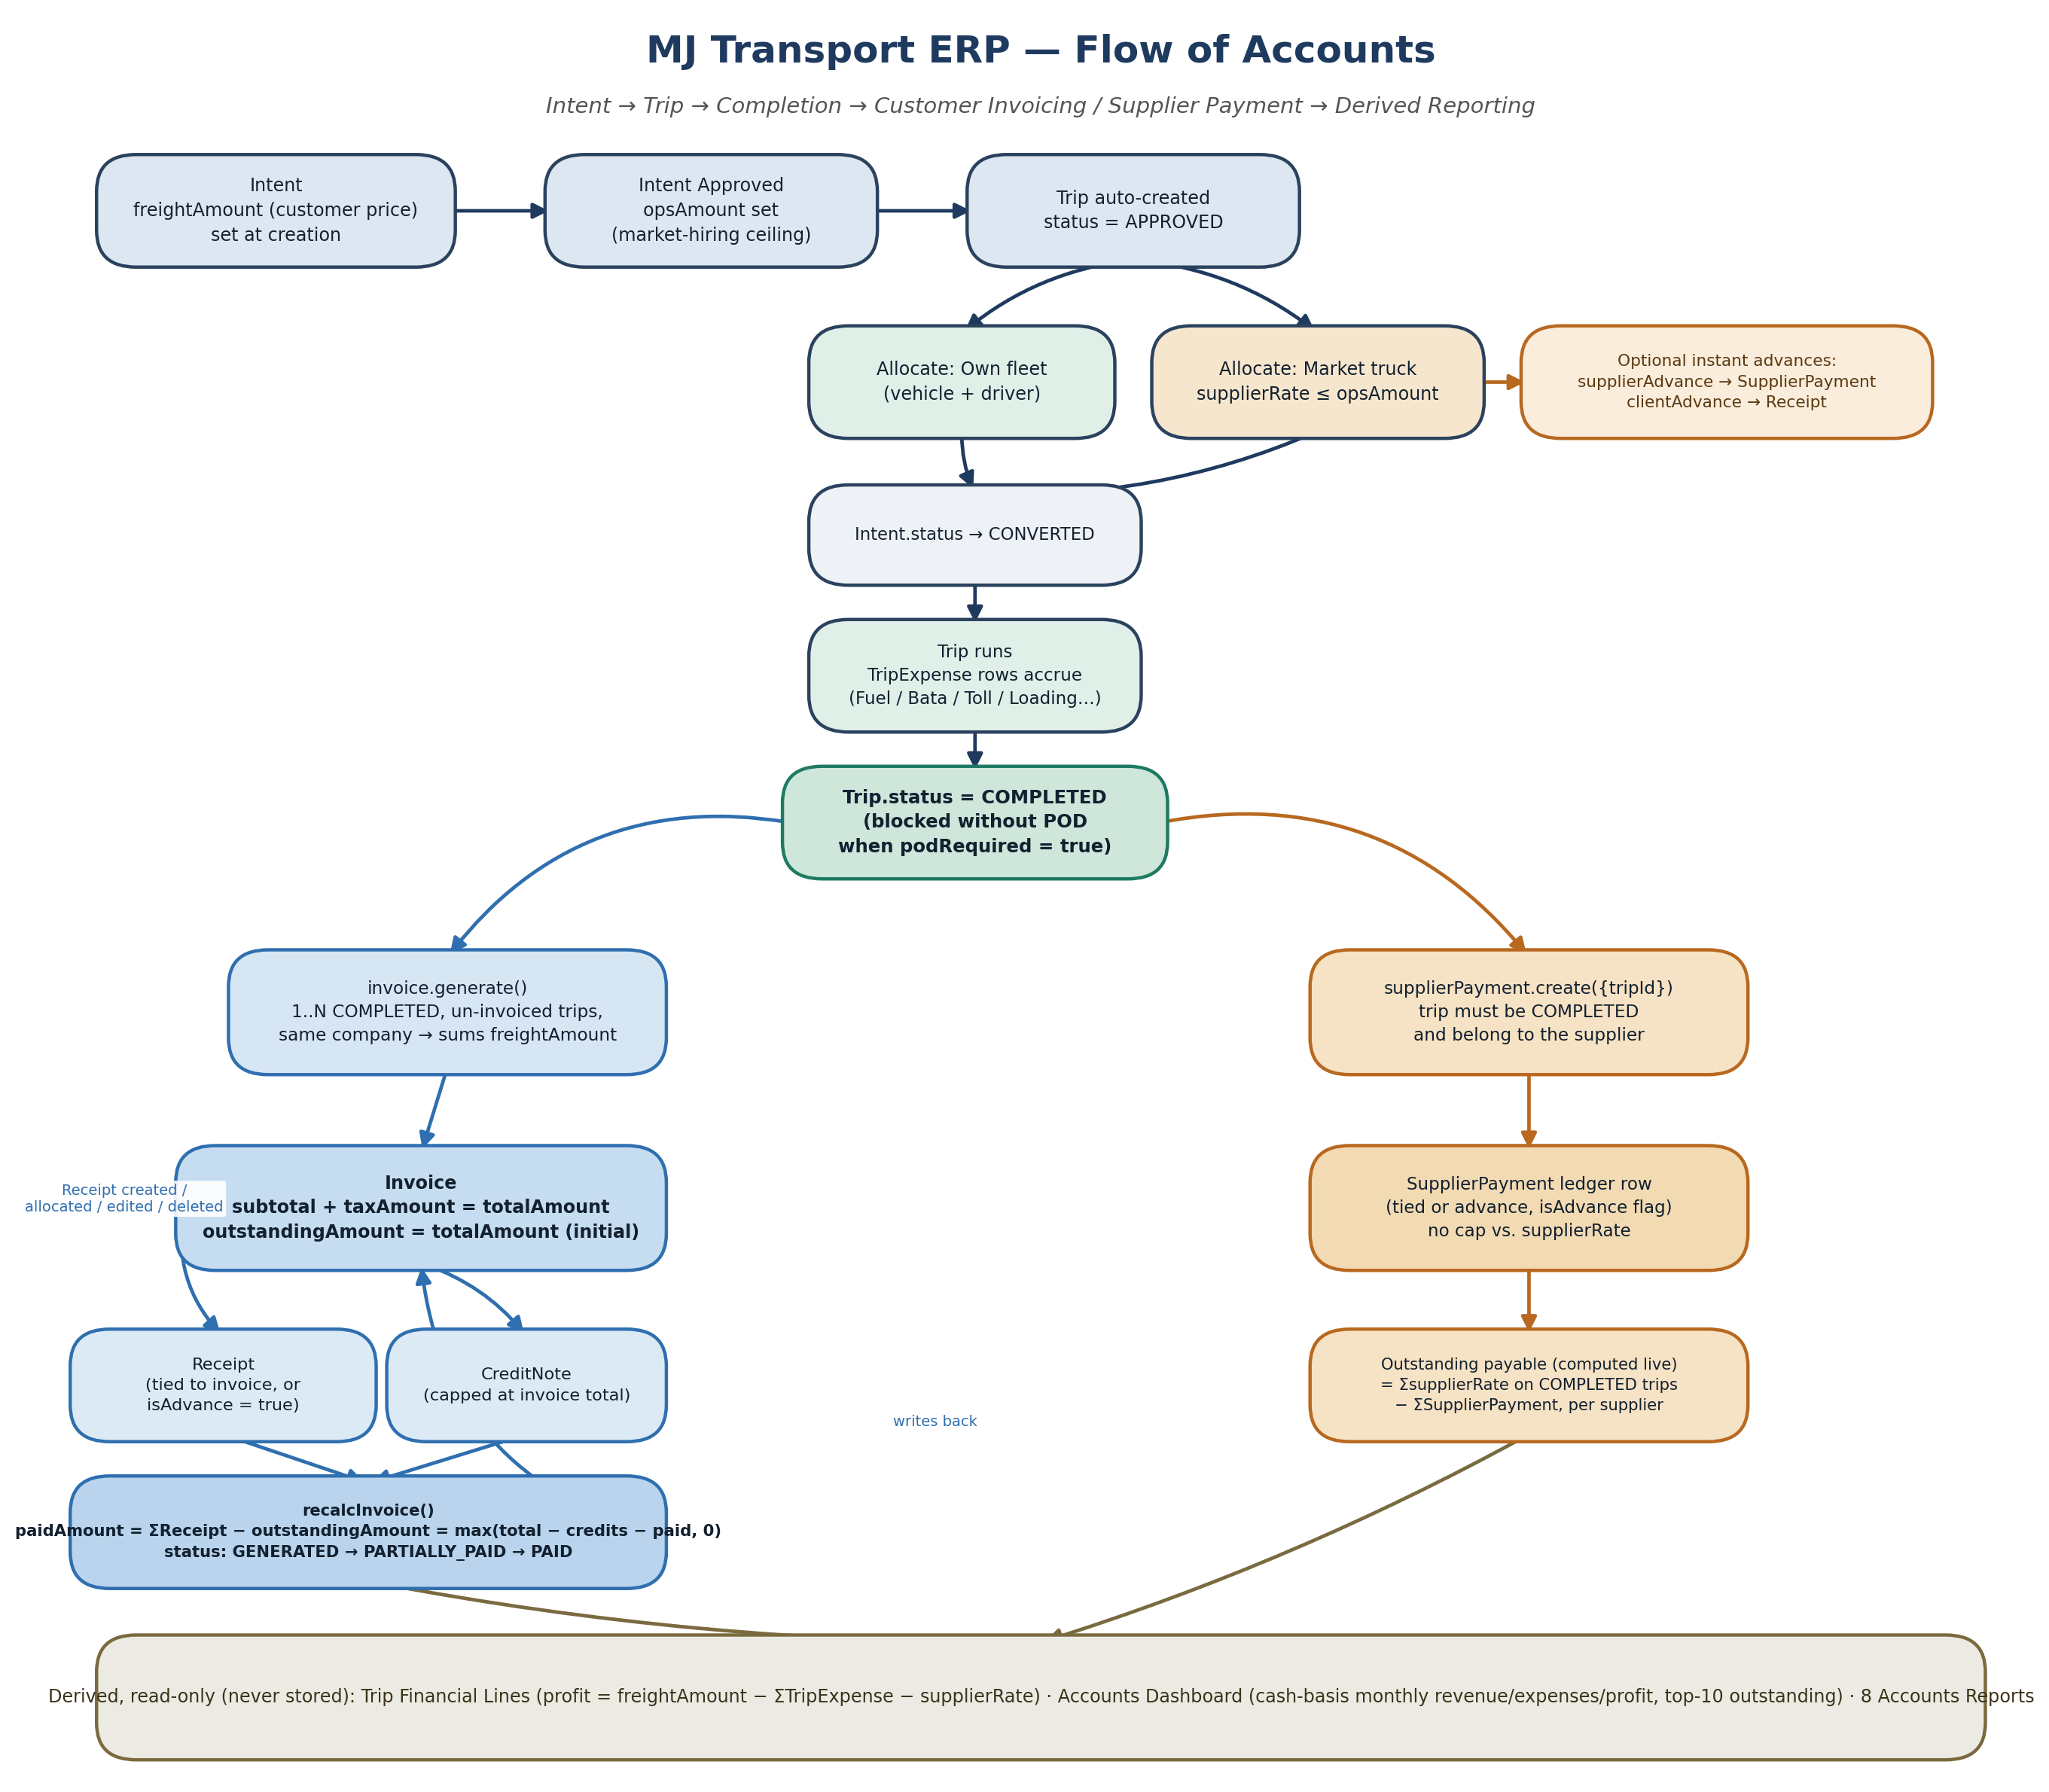
Figure 1. End-to-end flow of accounts — Intent through completion to invoicing, supplier payment, and derived reporting.

2. Design Philosophy
The schema itself documents the intended scope, in a comment directly above the Phase 6 (Accounts) block of prisma/schema.prisma:
This is deliberately NOT general-purpose accounting software — only
the transportation billing/settlement cycle: completed trips ->
customer invoice -> receipts, and completed supplier trips ->
supplier payments. Trip P&L (income/expenses/supplier charges/
profit) is intentionally NOT a stored table — it's computed on
demand from Trip + TripExpense + supplierRate, which are already
the single source of truth from Phase 5.
Everything that follows is a direct consequence of that one design decision: no ledger, no posting rules, two cash tracks keyed off the Trip record, and a reporting layer that recomputes rather than reconciles.

3. Upstream Trigger — How a Trip Becomes Billable
Nothing in Accounts originates on its own — every invoice line and every supplier payment traces back to a Trip produced by Operations:
- Intent created by an Intent Creator — freightAmount (what the customer will be billed) is fixed here, either directly or summed from itemized charges (base freight + toll + loading + other charges).
- Intent approved by an Operation Manager — sets opsAmount, the ceiling that a market-truck hiring cost may not exceed. This is a different figure from freightAmount: one is billed out, the other is a spending cap.
- Approval auto-creates a Trip (still unassigned).
- Allocation: on the own-fleet path a vehicle and driver are assigned, with no supplier cost. On the market-truck path (only permitted once no own vehicle is free), the agreed rate becomes Trip.supplierRate, validated ≤ Intent.opsAmount. Allocating a market truck can immediately spin off an advance Supplier Payment and/or an advance Receipt in the same call — the earliest point money can move, before the trip has even started. Either allocation path flips the source Intent to CONVERTED.
- The trip runs through its status machine, accumulating TripExpense rows (Fuel / Driver Bata / Toll / Loading / Unloading / Miscellaneous) along the way — this is what Accounts later nets against revenue.
- COMPLETED is a gate, not just a label: the transition is blocked if podRequired is true and no POD document has been uploaded. Only COMPLETED trips are eligible for invoicing or supplier payment.
This means Accounts is structurally incapable of billing a trip that hasn't proven delivery — the control is enforced upstream in Operations, not duplicated in Accounts.

4. Customer Side — Invoice → Receipt Cycle

4.1 Invoice Generation
Input: a company and a list of trip IDs. The service validates every trip: exists, status = COMPLETED, not already invoiced, and belongs to the selected company.
subtotal = Σ trip.freightAmount
taxAmount = subtotal × gst.ratePercent / 100 (if a GST master is chosen)
totalAmount = subtotal + taxAmount
outstandingAmount = totalAmount (at creation)
One invoice can bundle several trips for the same company; a trip cannot be split across invoices or invoiced twice.

4.2 Invoice Lifecycle
DRAFT → GENERATED → SENT → PARTIALLY_PAID / PAID, with CANCELLED reachable from any non-PAID state.
- send() is only allowed from GENERATED.
- cancel() is blocked once any receipt has been allocated (paidAmount > 0) and once PAID/already CANCELLED; cancelling unlinks the trips, freeing them to be re-invoiced.
- remove() only works once CANCELLED (soft delete).
- update() is blocked once PAID or CANCELLED — only due date and notes remain editable.

4.3 Recalculation Engine (recalcInvoice)
This is the core of the receivables ledger. It runs after every Receipt create / update / delete / allocate, and after every Credit Note:
paidAmount = Σ Receipt.amount for this invoice
creditedAmount = Σ CreditNote.amount for this invoice
netTotal = invoice.totalAmount − creditedAmount
outstandingAmount = max(netTotal − paidAmount, 0)
status:
outstandingAmount <= 0 -> PAID
else if paidAmount > 0 -> PARTIALLY_PAID
else if was PAID/PARTIALLY_PAID -> reverts to GENERATED
Invoice.paidAmount / outstandingAmount / status are therefore always derived, never hand-edited — the only two write paths into an invoice's money are receipts and credit notes.

4.4 Credit Notes
- Blocked against CANCELLED invoices.
- Capped: amount ≤ outstandingAmount + paidAmount (cannot exceed the invoice's original total).
- Triggers recalcInvoice() immediately.

4.5 Receipts
- Tied receipt: invoice ID provided → validated same company, invoice not cancelled → isAdvance = false → triggers recalcInvoice().
- Advance receipt: no invoice ID → isAdvance = true, held against the company only.
- allocate(receiptId, invoiceId): the only way an advance receipt gets tied to an invoice after the fact. Only callable on advance receipts; validates same company and invoice not cancelled; flips isAdvance off and triggers recalcInvoice() on the target invoice.
- update() / remove() both re-trigger recalcInvoice() on the affected invoice, so editing or deleting a receipt correctly reopens the invoice's outstanding balance.

5. Supplier Side — Payment Cycle
The supplier payment service is deliberately simpler than the invoice side — there is no “supplier invoice” document, no status machine, and no recalculation cascade. A Supplier Payment is a flat ledger entry:
- Tied payment: trip ID provided → trip must belong to the named supplier and be COMPLETED → isAdvance = false.
- Advance payment: no trip ID → isAdvance = true (exactly the path used at market-truck allocation time, before the trip has even started).
No cap is enforced against Trip.supplierRate — nothing stops a payment exceeding the trip's rate, and nothing stops multiple payments against the same trip. “Outstanding payable” is computed separately, at read time (Section 6), rather than stored on the trip or payment.

6. Derived Views (Computed On Demand, Never Stored)

6.1 Trip Financial Line
income = Trip.freightAmount
tripExpenses = Σ TripExpense.amount (undeleted)
supplierCharges = Trip.supplierRate
profit = income − tripExpenses − supplierCharges
Grouped three ways for the Trip Financials page/report: by vehicle, by supplier, and by customer — each sums the same four numbers per group over completed trips in an optional date range.
This deliberately ignores SupplierPayment/Receipt entirely — P&L is an accrual view off Trip + TripExpense, while Invoice/Receipt/SupplierPayment track cash movement against that accrual. The two are related but not reconciled against each other anywhere in the code.

6.2 Accounts Dashboard
- Outstanding Receivables = Σ Invoice.outstandingAmount, excluding cancelled invoices.
- Outstanding Payables = per supplier, Σ supplierRate across COMPLETED trips minus Σ SupplierPayment ever recorded — computed in memory, not a stored balance.
- Monthly Revenue = Σ Receipt.amount this calendar month (cash received, not invoiced amount).
- Monthly Expenses = Σ TripExpense.amount + Σ SupplierPayment.amount this month.
- Profit (dashboard tile) = monthlyRevenue − monthlyExpenses — a cash-basis figure, distinct from the trip-level accrual profit in Section 6.1.
- Top-10 customer outstanding, top-10 supplier outstanding, and the 10 most recent receipts/payments as activity feeds.

6.3 Accounts Reports
Report | Source | What it shows
Customer Outstanding Report | Invoice | Invoices with outstandingAmount > 0, not cancelled
Supplier Outstanding Report | Trip + SupplierPayment | Charge-minus-paid, per supplier (same logic as the dashboard)
Invoice Report | Invoice | All invoices, filterable by status / company / search
Receipt Report | Receipt | All receipts with linked invoice number
Payment Report | SupplierPayment | All supplier payments with linked trip number
Trip Profitability Report | Trip + TripExpense | Income / expenses / supplier charges / profit, per trip
Revenue Report | Trip | Freight amount per completed trip
Expense Report | TripExpense | Trip expenses by category

7. Access Control on Accounts Data
Two independent layers, both enforced server-side:
- Permission strings checked by the authorize() middleware on every route: invoice.view/create/edit/delete/cancel, creditNote.view/create, receipt.view/create/edit/allocate, supplierPayment.view/create/edit, tripFinancial.view, accounts.dashboard, accounts.view.
- Group scoping, applied on top of permissions for company-facing data (invoices, receipts): the ACCOUNTS_EXECUTIVE role is group-scoped — restricted to invoices/receipts whose company falls inside their own Group. A user with this role but no group membership sees nothing (fails closed). ACCOUNTING_MANAGER, ADMIN, SUPER_ADMIN and OPERATION_MANAGER are unrestricted.
- SupplierPayment has no equivalent scoping — suppliers aren't attached to a Group/Company the way customer-facing Companies are.

8. Every State Change Is Audited
Every mutating Accounts action — generate, update, send, cancel, remove, addCreditNote on invoices; create, update, allocate, remove on receipts; create, update, remove on supplier payments — writes an AuditLog row: actor, action, entity type/ID, and a human-readable description. Cancellations, deletions and reallocations all leave a trail; there is no soft-delete-and-forget path.

9. Frontend Surface
Page | Backed by | Purpose
Accounts Hub | — | Landing/navigation tile for the module
Accounts Dashboard | GET /api/accounts/dashboard | Revenue vs. collection vs. payments chart, profit analysis, customer/supplier outstanding lists, recent activity feeds
Customer Invoices | invoice.routes.ts | List + “Generate Invoice” dialog (company → eligible completed trips → optional GST → preview) + send/cancel/credit-note actions
Customer Receipts | receipt.routes.ts | List filterable by Advance/Allocated, create/edit/delete, allocate-to-invoice action
Supplier Payments | supplier-payment.routes.ts | List + create/edit/delete, tied to a trip or left as an advance
Trip Financials | trip-financial.routes.ts | Per-trip income/expense/supplier-charge/profit breakdown
Accounts Reports | accounts-report.repository.ts | The 8 tabular reports in Section 6.3, with export

10. Notable Design Choices and Gaps
Worth flagging to anyone extending this module:
- No general ledger / chart of accounts — by design. Adding one would be a significant departure, not an incremental extension.
- Two different “profit” numbers coexist: the accrual per-trip profit (freightAmount − expenses − supplierRate) and the cash-basis dashboard profit (monthly receipts − monthly expenses). They will not reconcile to the same figure, and nothing in the code attempts to reconcile them.
- SupplierPayment has no ceiling check against Trip.supplierRate, unlike the customer side where Invoice.outstandingAmount is strictly derived. Overpaying a supplier is possible and silent.
- Outstanding payable is a live, in-memory computation, not a stored balance — fine at current scale, but worth revisiting if trip/supplier volume grows large.
- VehicleExpense vs. TripExpense are intentionally separate: the former is the vehicle's lifetime cost ledger (Fleet module, fed automatically from fuel and maintenance records), the latter is trip-scoped P&L (Accounts, entered independently in Operations). The two are not the same numbers and should not be confused when reading reports.

